NORTHFIELD CENTER TOWNSHIP
8484 Olde Eight Rd., Northfield Center, Ohio 44067
Phone: 330 467-7646 E-mail: nctsecretary@northfieldcenter.com View Zoning Resolution at: www.northfieldcenter.com

APPLICATION FOR ZONING PERMIT/CERTIFICATE

Applicant
Address | Phone:
E-mail
Property Owner Name Signature: Phone:
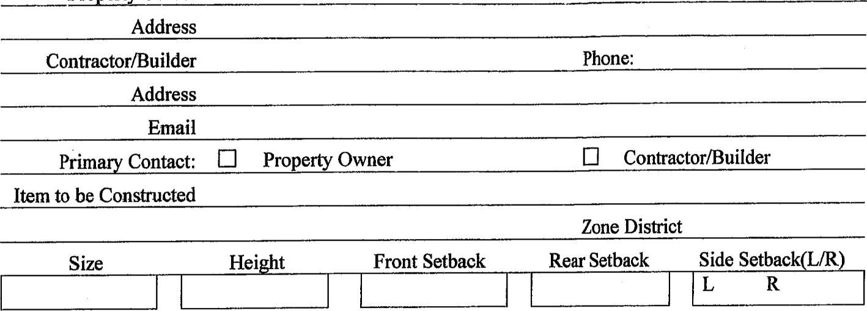
INFORMATION REQUIRED FOR PERMITTED ACCESSORY USE ZONING PERMIT
l. A site plan showing dimensions of lot: dimensions of existing and proposed buildings, setback building lines and exact locations of all structures.
- Diagrams and/or pictures of proposed fences, signs.
- Heights where applicable.
- Complete description of proposed project (size, footage, etc.)
- Riparian Assessment form from Summit Soil and Water
6. Permit fee must accompany this application.
Date Received: | Check # Cash ^{Amount}
The undersigned hereby applies for a Zoning Certificate for above use. Certificate will be issued on the basis of plan attached hereto and the representations contained herein, all of which the applicant swears to be true.
This is a Northfield Center Township Zoning Certificate Application. Summit County Building Permit may be required.
Contact the Summit County Building Dept. to determine if a building permit is necessary at 330-630-7280.
Signature of Applicant ________________________________________________________________

***Zoning office will contact applicant when permit is approved.***
NCT Zoning Resolution Sec. 610.01 “Zoning Certificate Required”
No land shall be disturbed, no building or structure shall be erected, constructed, enlarged, structurally altered, or moved in whole or in part and, no use shall be established or changed in the unincorporated area of Northfield Center Township prior to the
issuance of a Zoning Certificate when required by this Chapter. Details can be found in NCT Zoning Resolution on website or at Administrative Offices.

